7.23: a) In this case, 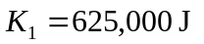 as before, 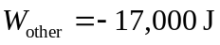 and
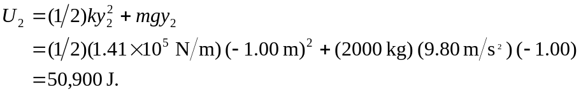
The kinetic energy is then , corresponding to a speed 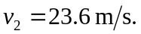 b) The elevator is moving down, so the friction force is up (tending to stop the elevator, which is the idea). The net upward force is then for an upward acceleration of 